**“Building A Simple Leather Bracelet at Home or In Camp”**

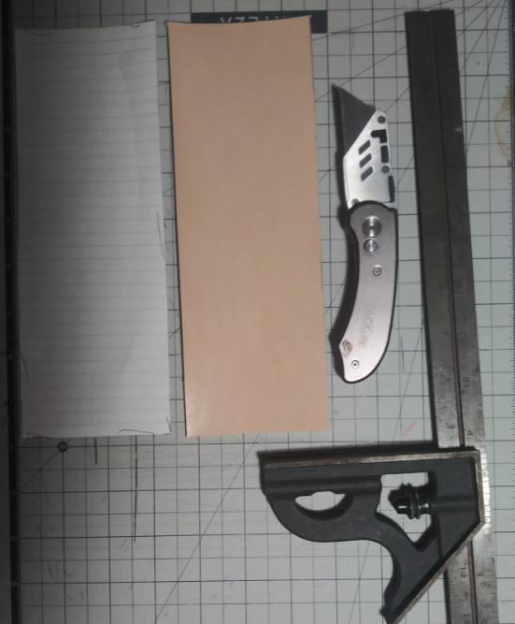

(1.) A friend of mine knew that I did a little leather work as a hobby so he asked if I would make him a classic just plain black leather bracelet. I had some spare 2-3 oz scrap leather laying around, so I got to work. First step is to use some scrap paper to make a pattern and get the length right since everyone doesn’t have the same size arm. The pattern needs to be the correct width and length as the customer wants the fit on their arm plus 1” extra for the snaps, this one turned out to be 9’’ long and 3 1/4” wide. After making the paper pattern, just transfer and cut out your leather. Just keep in mind the color that you will be dying the leather because if you use a black pen to make your marks and then dye the leather saddle tan marks will show through. The best idea is to use a pencil or a leather marking pen for lighter dye colors.

(2.) Then of course you want to lay out your holes for the snaps. The hole can be made by a simple punch that can be bought at most craft stores or the proper size nail for the size holes that you need for the snaps being used.

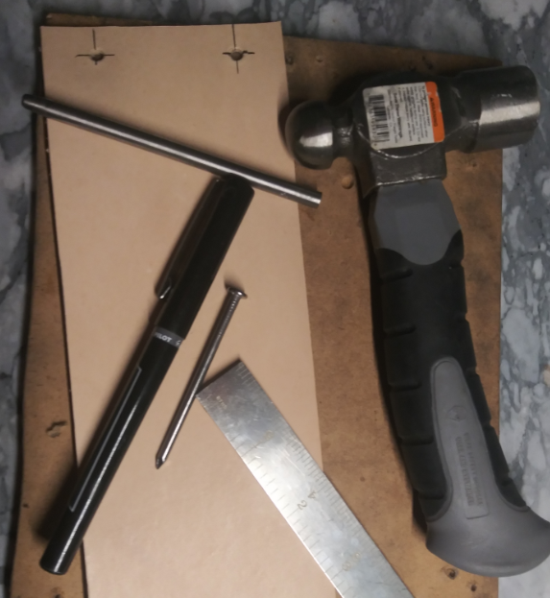

(3.) Next you will want to die your leather, I prefer the Fiebings leather dyes myself, but you can find many brands online and at craft stores at different cost. Natural made dyes can also be used but you can write an entire article on what all of those are and how to make them correctly. Try not to overload your leather with dye, just use enough to get the color you desire.

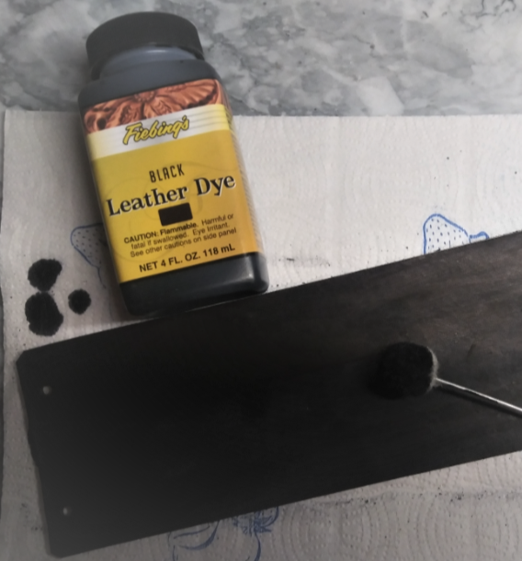

(4.) After the dye has dried, you will want to install your snaps. These also can be bought at your local craft store or online, in many different colors and sizes. When you buy a set of snaps you usually also receive the installation die and punch. Just be careful to install your snaps facing the correct way so the side of the leather you want on the outside is facing out. Some people like the fleshy side on the outside and some prefer the smooth side of the leather facing out.

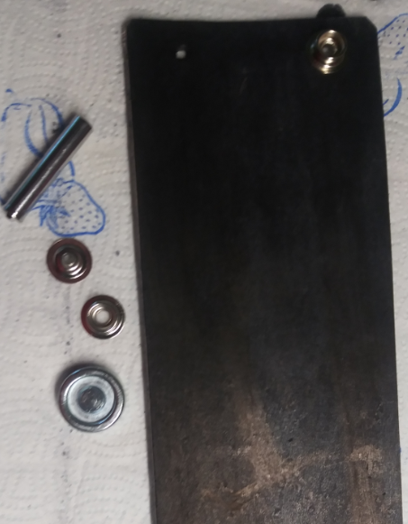

(5.) Next you will want to do your finish work. Burnish the edges with a small smooth piece of rounded wood as shown in my picture, or you can also buy a burnisher that will fit in a small drill or hobby press to smooth out your edges. I then like to coat my project with a thin film of bees wax and slightly heat it with a small craft torch so I can use a course rag to polish in the bees wax and give the leather a nice sheen and protection coat.

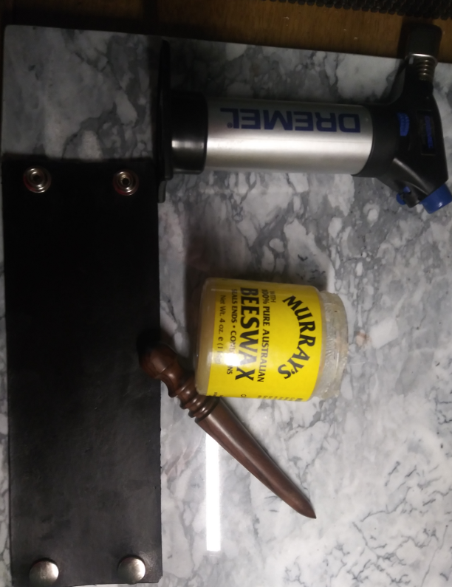

Finally! the finished product..

